Ismail FARUK 260663521

Mohamed Reda EL KHILI 260678513

François-Eliott ROUSSEAU 260670000

LAB 2 Report - ECSE 403

1)

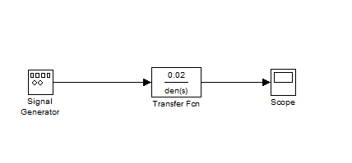

Figure 1: Diagram with transfer function derived from lab 1

2)

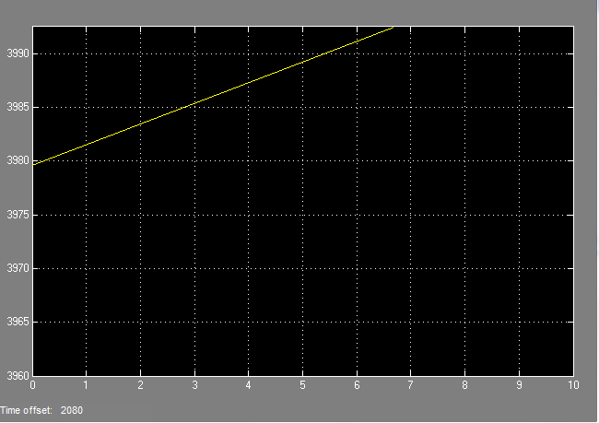

Figure 2: Response to the unit step function

We can see that the response of the system to a unit step function is an integrator. Therefore, we can conclude that there is no rise time and that the steady state response is infinite.

3) In order to obtain the necessary data to plot the magnitude Bode Diagram, we measured the amplitude for each frequency. Then, we plotted a graph with 10log10(input frequency) as the x-axis and 20log(Amplitude) as y-axis.

We got:

|  |  |
| --- | --- |
| Frequency | Amplitude |
| 0.1 | 14 |
| 1 | 0.1985 |
| 10 | 2.10-3 |
| 100 | 0 |
| 1000 | 0 |

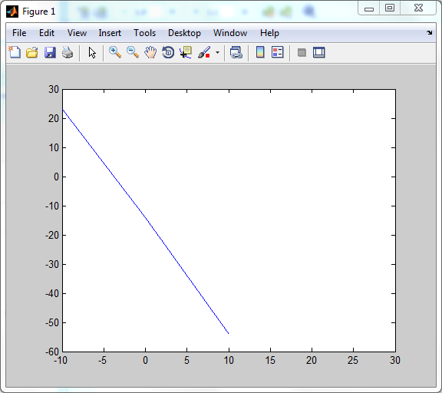

Figure 3: Experimental Bode Diagram

Then, we use the bode(sys) function on MATLAB to obtain the theoretical bode plot.

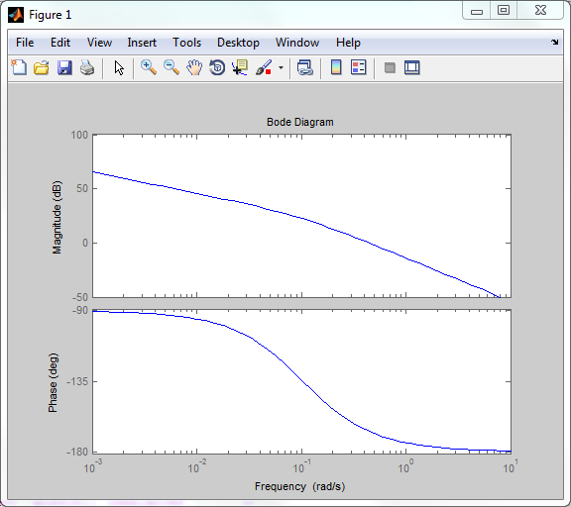

Figure 4: Theoretical Bode Diagram

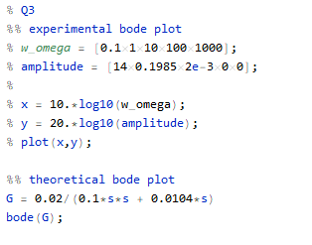

4) Following the same steps as the previous question, we obtained the following values:

|  |  |
| --- | --- |
| Frequency | Amplitude |
| 0.1 | 1.17 |
| 1 | 0.785 |
| 10 | 0.653 |
| 100 | 2.51 |
| 1000 | 0.0135 |

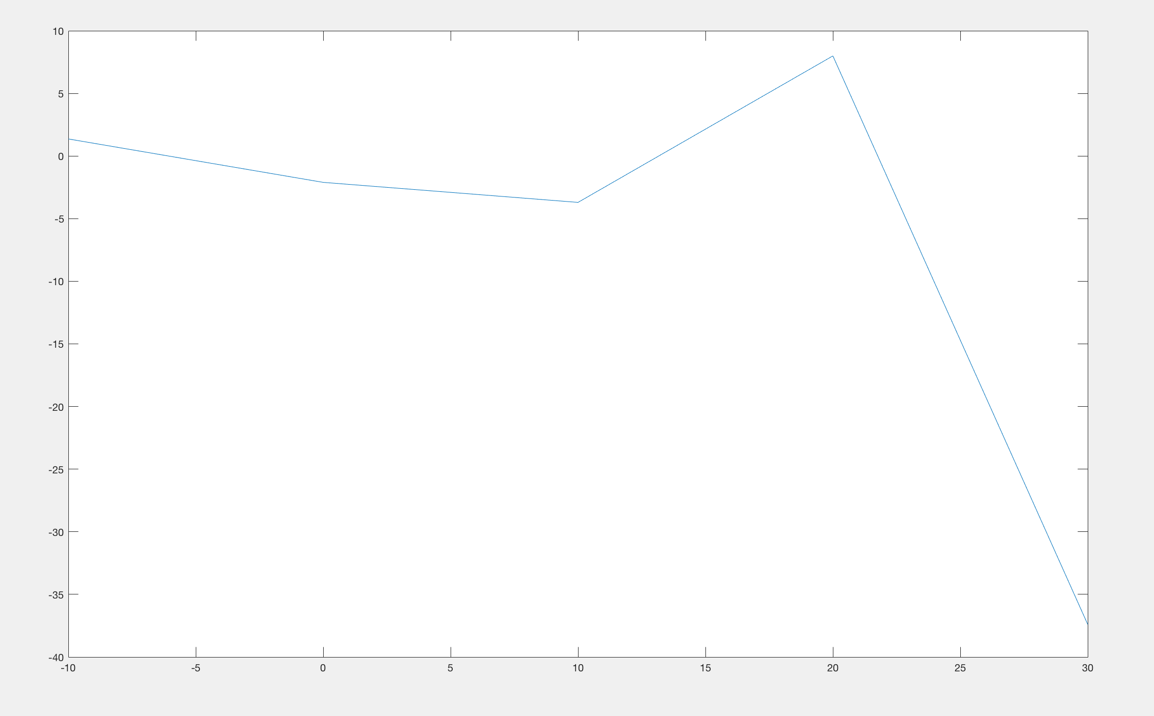

Figure 5: Experimental Bode Diagram

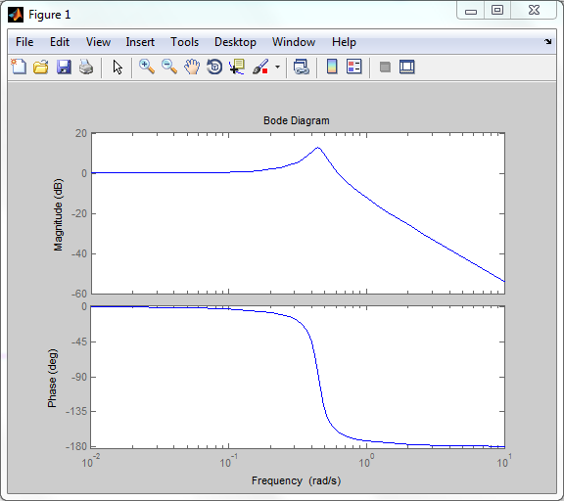

Figure 6: Theoretical Bode Diagram

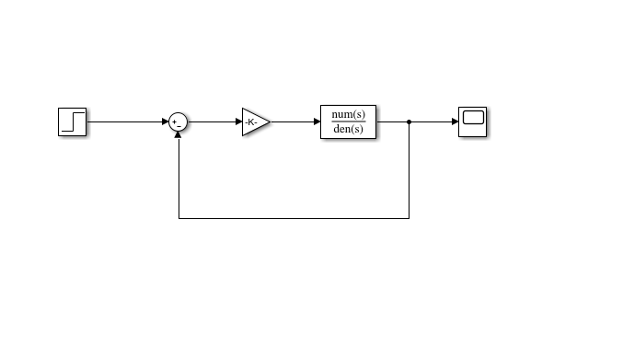

Figure 7: Simulink Model for question 4 to 6

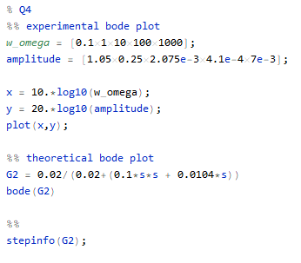

5) Rise time 4 *s*

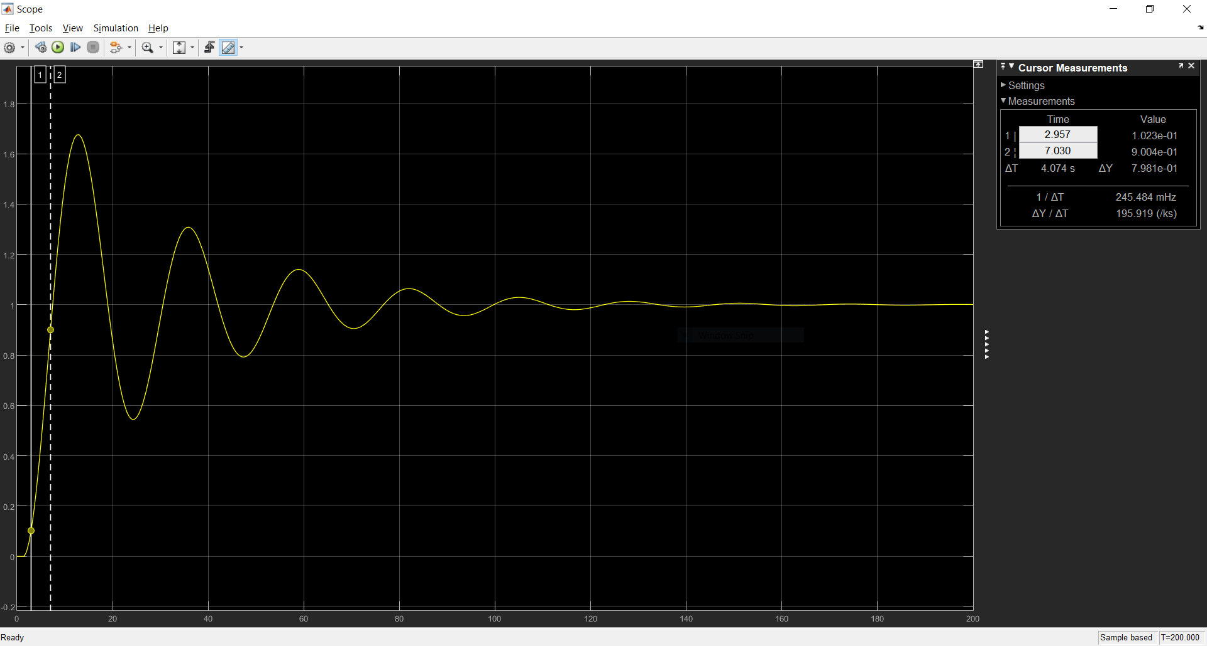

Figure 8: Scope with P controller, K = 0.37

Rise time is the time difference for change in system from 10% to 90% of steady-steady value. Figure 8 is for a system with gain K = 0.37 and unit feedback. We can see in Figure 9 that the time difference = 4 *s* (approximately).

6) Overshoot 20%

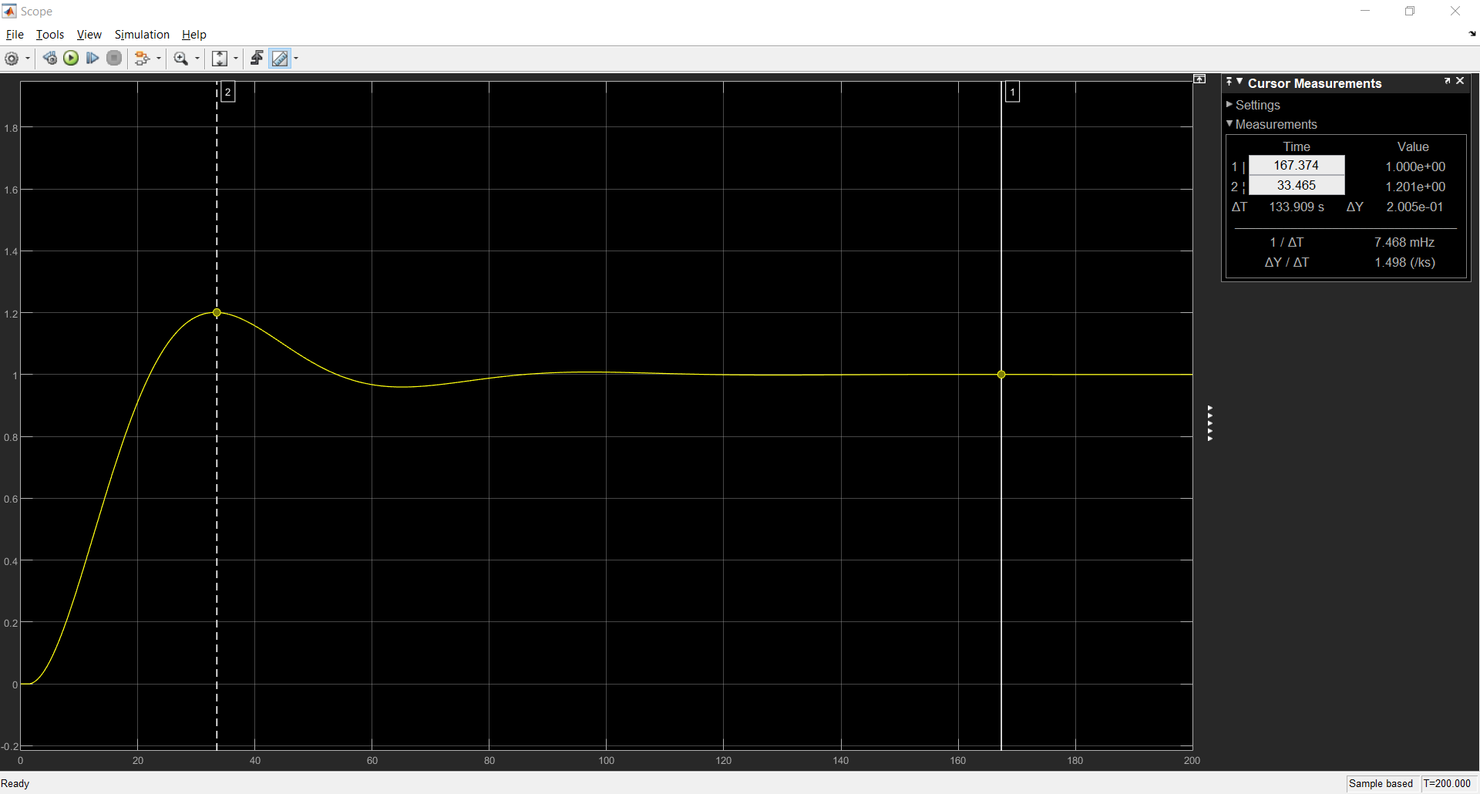

Figure 9: Scope with P controller, K = 0.0595

Overshoot being the maximum value of output the system gives more than steady-state, we can see from Figure 9, that for overshoot 20%, the applied gain K =0.0595.

7) Effects of PID controllers

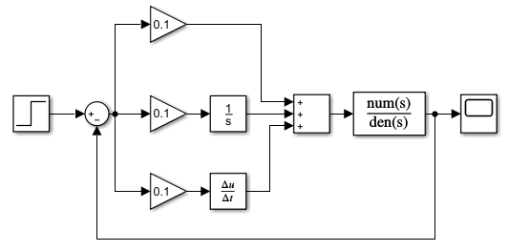

Figure 10: Model for PID controller











Keeping Kp and Kd constant, increasing Ki decreases Rise Time, Overshoot and Settling TIme and also eliminates Steady-State error.

Keeping Kp and Ki constant, increasing Kd decreases Overshoot and Settling Time.

8) With Derivative Gain Kd = 0

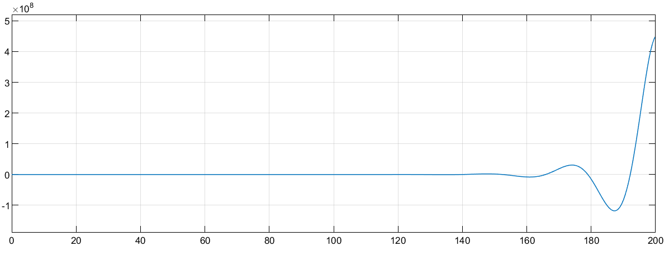

Figure 32: Kp = 0.1, Ki = 0.1, Kd = 0

With Kp = 0.1 and Ki = 0.1, we can see that for a Kd = 0, we get a very high rise time and a decrease in overshoot and settling time.

9) With Integrator Gain Ki = 0

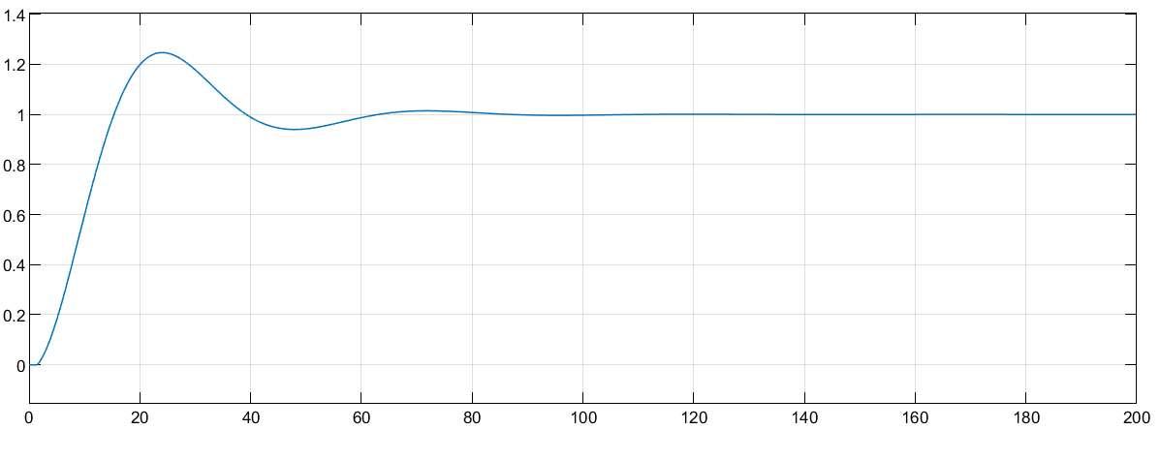

Figure 33: Kp = 0.1, Ki = 0.1, Kd = 0

For Kd = 0.1 and Kp = 0.1, we can see that for a Ki = 0, we get a low rise time and a high overshoot.

10) We followed the lab manual instructions and observed the output of the system. (Verified by the TA)

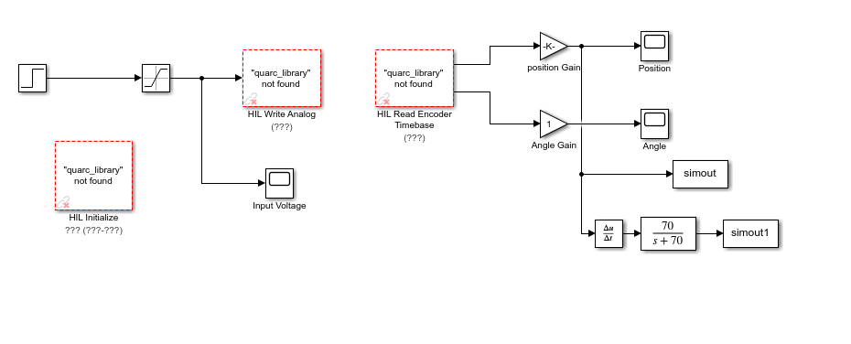

Figure 34: Simulink Model for question 10 to 14

11) The goal is to find the linear gain position such that we can observe the output in terms of centimeters. After measuring the distance traveled with a ruler for a position gain of 1, we obtain a scale of 45.5 units per centimeters travelled. Hence, dividing 1 by 45.5, we obtain the linear position gain of **0.022**.

12)

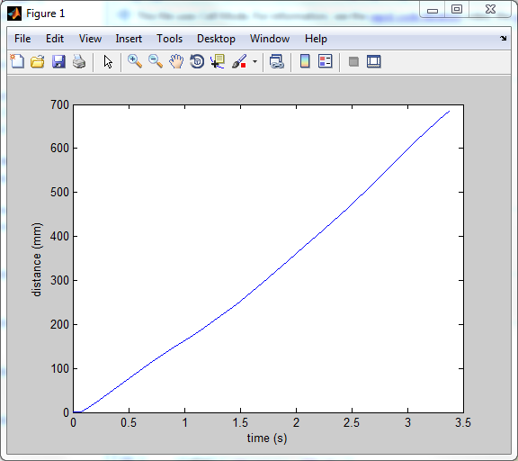

Figure 35: Step-Response of the System in terms of distance

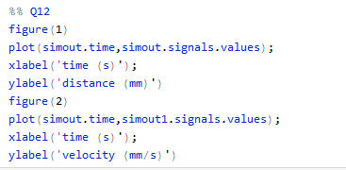

13) We obtain the velocity as output of the system by adding a divider to the model since we had a model that had the position as output of the system.

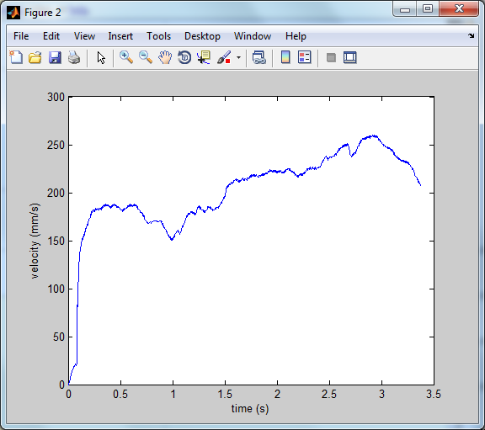

Figure 36: Step Response in terms of velocity

14) The observed velocity on the scope is noisy because we are converting digital input signals to analog signals. We can also assume that the friction of the cart can be another source of noise.